**WEEK 6, Lab R Sessions, Spatial Stream Networks**

Hi everyone!

For this R session, we’re going to be working with regression analyses in stream networks while also accounting for spatial autocorrelation. There are several R packages that we’ll be using for these purposes. Please make sure you install packages “**SSN**”, ”**stars**”, and “**openSTARS**” prior to moving forward in this document.

Package “**openSTARS**” is available here: <https://github.com/MiKatt/openSTARS>. This link will take you to the GitHub page that provides a vignette of how to prepare your data (what we’ll be following today) and a troubleshooting guide for any package-specific errors you may receive. You can also download “**openSTARS**” by first loading package “**devtools**”, then using the following command:

devtools::install_github("MiKatt/openSTARS")

library("openSTARS")

In addition to installing the aforementioned R packages, you’ll also need to install GRASS. I have very little experience working with this program, but it is supposedly very powerful for geospatial analyses. It also has a reputation of being extremely finicky.

Please download the appropriate version of GRASS for your computer here: ([https://grass.osgeo.org/#](https://grass.osgeo.org/)). Once GRASS is installed, you’ll also need to install several add-on packages. These add-ons are:  r.stream.basins, r.stream.distance, r.stream.order, and r.hydrodem.

The following is a quick walkthrough for setting up GRASS:

1. Go to GRASS website

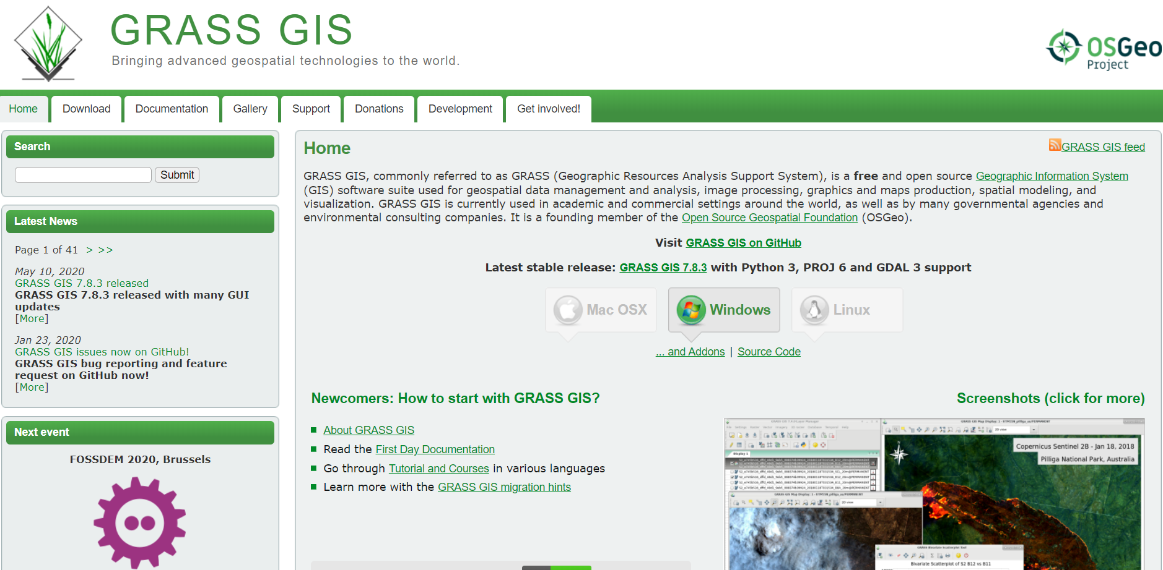

1. Download GRASS – I’ve found that version 7.6 works very well, 7.8 may work for you. 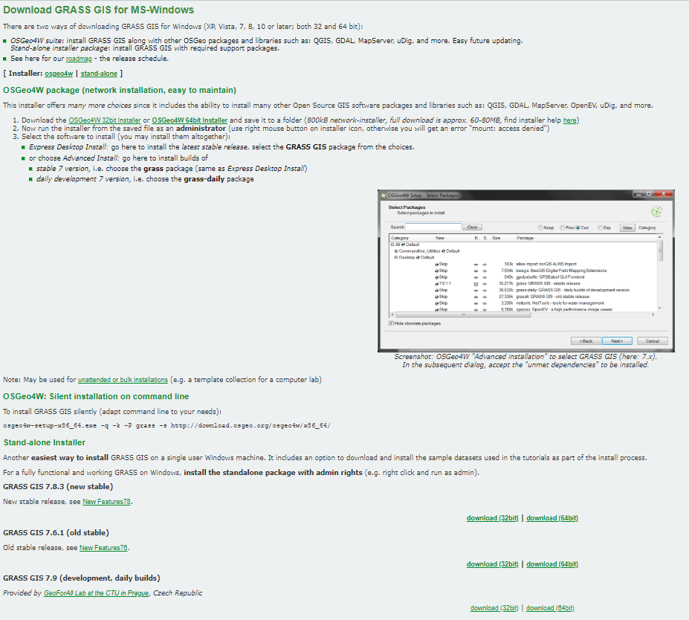
2. Save in your computer’s “Program Files” or its Mac equivalent. Run the installer program (.exe), this is a fairly easy process



1. Open GRASS, start a new session, install the following add-ons to use “openSTARS” -  [r.stream.basins](https://grass.osgeo.org/grass74/manuals/addons/r.stream.basins.html), [r.stream.distance](https://grass.osgeo.org/grass74/manuals/addons/r.stream.distance.html), [r.stream.order](https://grass.osgeo.org/grass74/manuals/addons/r.stream.order.html) and [r.hydrodem](https://grass.osgeo.org/grass74/manuals/addons/r.hydrodem.html) 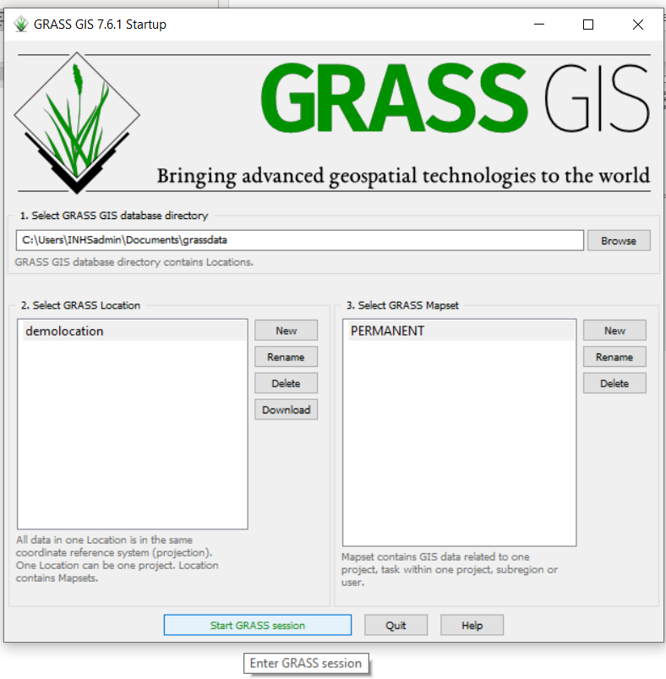
2. Go to “Settings”, then “Addons extension”, and finally “install extension from address”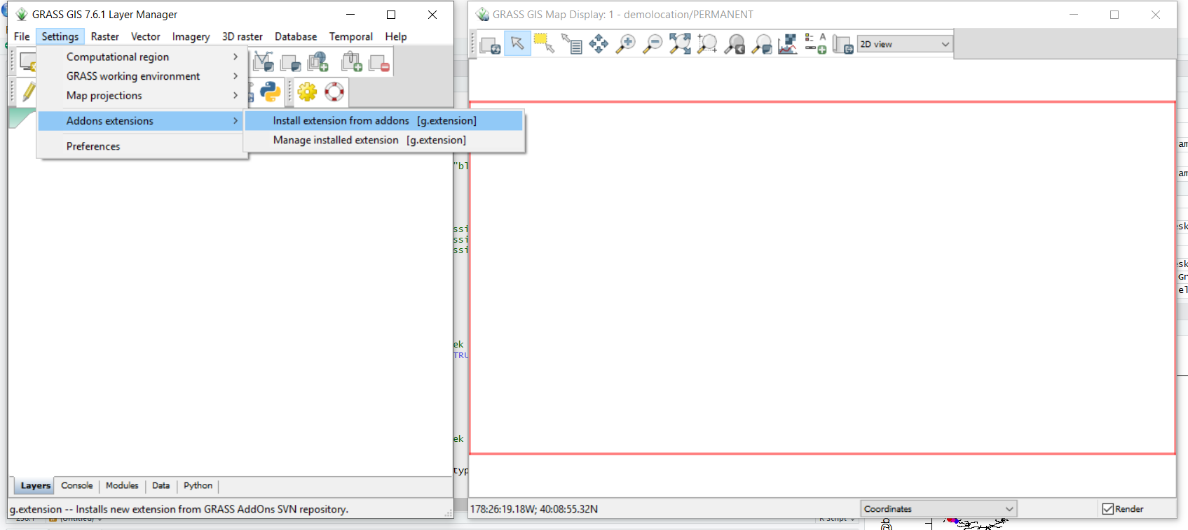
3. Locate the required extensions under the “raster” dropdown, double-click to install the required addons ([r.stream.basins](https://grass.osgeo.org/grass74/manuals/addons/r.stream.basins.html), [r.stream.distance](https://grass.osgeo.org/grass74/manuals/addons/r.stream.distance.html), [r.stream.order](https://grass.osgeo.org/grass74/manuals/addons/r.stream.order.html) and [r.hydrodem](https://grass.osgeo.org/grass74/manuals/addons/r.hydrodem.html))

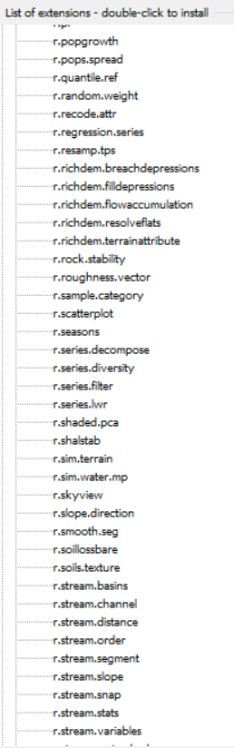

**Once you have installed the addons, you can now close GRASS!**

You’ll also need a digital elevation model (DEM) for Illinois. That can be found here: <https://clearinghouse.isgs.illinois.edu/data/elevation/surface-elevation-30-meter-digital-elevation-model-dem>

I’ve also provided you with a pre-prepared version of this model in the folder titled “GRASS Ready”